H.T No
Regulations:
A18

Sreenidhi Institute of Science and Technology
(An Autonomous Institution)
Code No: 7F302 Date: 08-Aug-2023 (FN)

B.Tech II-Year I- Semester External Examination, Aug - 2023 (Supplementary)
DISCRETE MATHEMATICS (CSE and IT)

Time: 3 Hours Max.Marks:70

Note: a) No additional answer sheets will be provided.
b) All sub-parts of a question must be answered at one place only, otherwise it will not be valued.
c) Missing data can be assumed suitably.

Bloom's Cognitive Levels of Learning (BCLL)

Remember | L1 | Apply | L3 | Evaluate | L5
Understand | L2 | Analyze | L4 | Create | L6

Part - A Max.Marks:20
Answer all QUESTIONS

 |  | BCLL | CO(s) | Marks
1 | Construct a truth table for the compound statement (p → q) ᴧ (˥ p → q). | L2 | CO1 | [2M]
2 | Define quantifier and its types. | L1 | CO2 | [2M]
3 | Draw the Hassle diagram for the divisibility relation on the set  A = {3,6,12,36,72}. | L2 | CO3 | [2M]
4 | State Pigeonhole principle. | L1 | CO4 | [2M]
5 | Solve a_{n}=2(a_{n-1}-a_{n-2}) for n≥2. | L3 | CO5 | [2M]
6 | Define Hamiltonian and planar graphs. | L1 | CO6 | [2M]
7 | State Tautology with an example. | L1 | CO1 | [2M]
8 | State Semi group with an example. | L1 | CO3 | [2M]
9 | Find the chromatic number of a wheel graph. | L2 | CO6 | [2M]
10 | Write any two properties of a binary relation. | L1 | CO3 | [2M]
Part – B Max.Marks:50
ANSWER ANY FIVE QUESTIONS. EACH QUESTION CARRIES 10 MARKS.

 |  |  | BCLL | CO(s) | Marks
11. | a) | Let p , q and r be the propositions.  P: you have the flu.  Q: you miss the final examination.  R: you pass the course.  Write the following proposition into statement form.  i) P → Q ii) ˥ P → R iii) Q → ˥ R iv) P V Q V R  v) ( P → ˥R ) V ( Q → ˥R) | L2 | CO1 | [5M]
 | b) | Prove that the following argument is valid.  If Rochelle gets the supervisor’s position and works hard, then she’ll get a raise. If she gets the raise, then she’ll buy a new car. She has not purchased a new car. Therefore either Rochelle did not get the supervisor’s position or she did not work hard. | L3 | CO1 | [5M]
12. | a) | Explain free and bound variables with an example. | L2 | CO2 | [5M]
 | b) | Show that the premises “Everyone in this Discrete Mathematics class has taken a course in computer science” and “Maria is a student in this class” imply the conclusion “Maria has taken a course in computer science.” | L3 | CO2 | [5M]
13. | a) | Let X = {1, 2, 3, 4, 5, 6, 7} and R= {(x, y)/ x-y is divisible by 3} in X.  Show that R is an equivalence relation? | L3 | CO3 | [5M]
 | b) | Define Lattice with an example. | L1 | CO3 | [5M]
14. | a) | What is the minimum number of students required in a course to be sure that at least six will receive the same grade, if there are five possible grades, A, B, C, D and F? | L3 | CO4 | [5M]
 | b) | A large software development company employs 100 computer programmers. Of them, 45 are proficient in Java, 30 in C#, 20 in Python, six in C# and Java, one in Java and Python, five in C# and Python, and just one programmer is proficient in all three languages above.  Determine the number of computer programmers that are not proficient in any of these three languages. | L2 | CO4 | [5M]
15. | a) | Solve the recurrence relation U_{n+1} - U_{n} = 3^{n}, n ≥ 0 where the initial condition is U₀ = 1. | L3 | CO5 | [5M]
 | b) | Solve a_{n} - 7a_{n-1} + 12a_{n-2} = 0 ∀ n ≥ 2, a₀ = 2, a₁ = 5 | L3 | CO5 | [5M]
16. | a) | Show that the following graphs G = (V,E) and H = (W,F) are not isomorphic  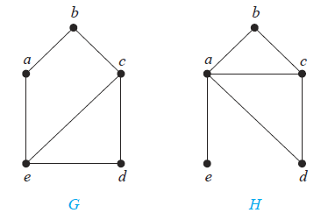 | L3 | CO6 | [5M]
 | b) | 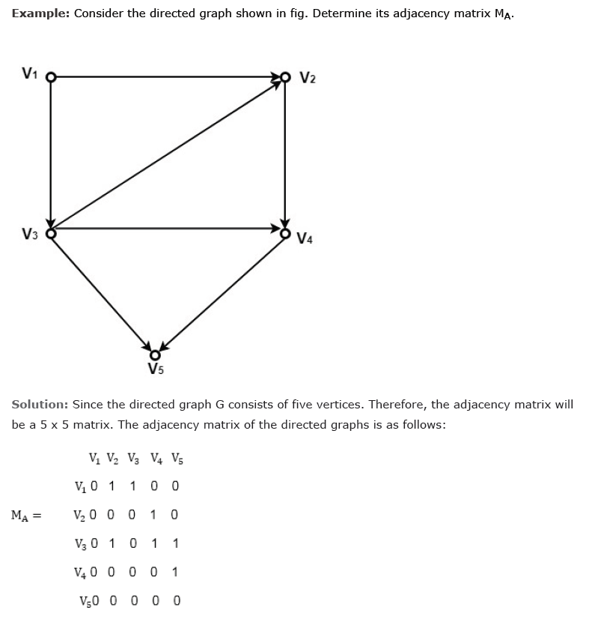  Determine the adjacency matrix A_{G} for the following directed graph G | L2 | CO6 | [5M]
17. | a) | Obtain the PDNF for the statement formula (p ^ q) v (~p ^ r) v (q ^ r) | L2 | CO1 | [4M]
 | b) | Write the negation of the following statement “if x is odd then x² – 1 is even” where the universe comprises all of the integers. | L2 | CO2 | [3M]
 | c) | Define f : (Z,+) → (Z,+) by f(x) = 5x. Prove or disprove: f is a homomorphism. | L2 | CO3 | [3M]
18. | a) | To buy a computer system, a customer can choose one of 4 monitors, one of 2 keyboards, one of 4 computers and one of 3 printers. Determine the number of possible systems that a customer can choose from. | L2 | CO4 | [4M]
 | b) | Solve the recurrence relation a_{n} - 5a_{n-1} + 6a_{n-2} = 0, a₀ = 2, a₁ = 5 | L3 | CO5 | [3M]
 | c) | Show that K_{3,3} is non-planar. | L3 | CO6 | [3M]

-- 00 -- 00 –

